**Name : Aarya Tiwari**

**Batch : B2:**

**Roll No. : 16010421119**

**Course: UIP**

**Experiment No. : 5**

**Output:**

**Drag and Drop:**

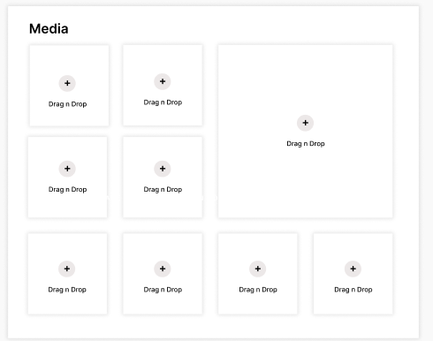

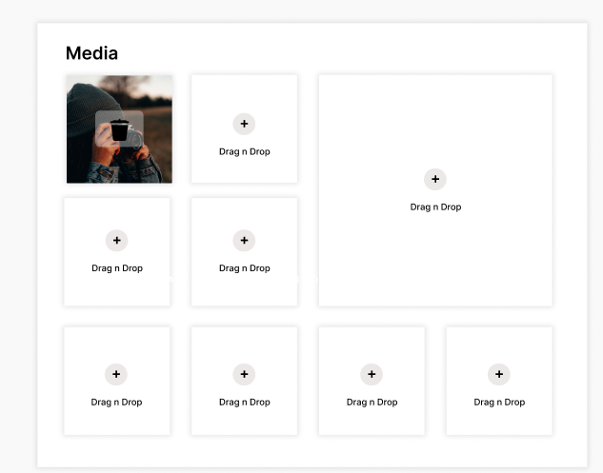

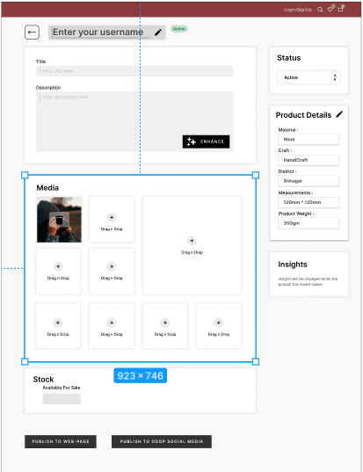

**This is a method to insert images   
considering a very common method of use , we have included this in our app to make it more easy to use.**

**Post Lab Questions:**

**1. Discuss in detail any one web development framework/technology to implement drag and drop principle.**

**Ans. One popular web development framework/technology for implementing the drag and drop principle is HTML5's Drag and Drop API. This API provides a set of events, objects, and methods that allow you to create interactive and user-friendly interfaces where users can drag elements and drop them into specific target areas. Let's discuss this technology in detail:**

**HTML5 Drag and Drop API:**

**The HTML5 Drag and Drop API is a built-in feature of modern web browsers, which means it doesn't require any third-party libraries or frameworks. It provides a straightforward way to enable drag-and-drop functionality on web pages.**

**Outcomes:**

**CO2: Apply principles of information organization and navigation along with data handling in web interface design**

**Conclusion:**

**We can conclude that we have learnt about the drag and drop principle in UI Design**